Number Theory
Fractions
Grades 4-6

Kathy Swanson
kswanson@proctor.k12.mn.us

Jess Kramer
jkramer@proctor.k12.mn.us

Anne Marie Bergman
abergman@proctor.k12.mn.us

Executive Summary: This project consists of two fraction units: Foundations of Fractions and Multiplication of Fractions. It incorporates project-based learning strategies and the use of manipulatives demonstrated in the Number Theory course. The Foundations of Fractions Unit includes identification and modeling of fractions multiple ways, understanding mathematical vocabulary related to fractions, using a number line to show fractions and mixed numbers, and addition and subtraction of fractions. The Multiplication of Fractions Unit includes multiplication of fractions, multiplication of whole numbers and fractions, and multiplication of fractions and mixed numbers.

Table of Contents:
Unit 1: Foundations of Fractions
- Day 1-3 Identifying and Modeling Fractions
- Day 4-5 Adding Fractions to Equal 1
- Days 6-10 Numerator/Denominator; Representing Fractions
- Day 11 Fractions on a Number Line
- Day 12 Equivalent Fractions
- Days 13-17 Addition and Subtraction of Fractions
- Day 18 Mixed Numbers and Improper Fractions
Unit 2: Multiplication of Fractions
- Days 19-21 Multiplying Fractions and Whole Numbers
- Days 22-23 Multiplying Fractions
- Days 24-25 Multiplying Mixed Numbers

MN K-12 Academic Standards:
- 5.1.2.3 Order fractions and decimals, including mixed numbers and fractions, and locate on a number line.
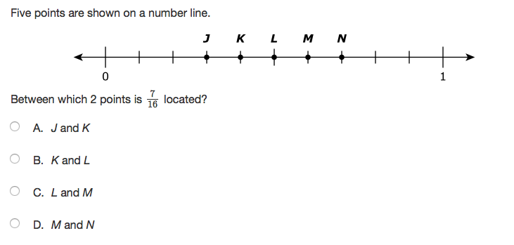
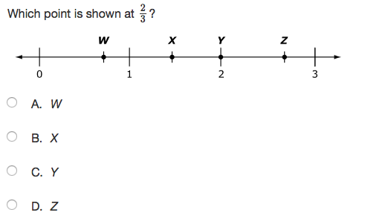

- 5.1.2.4 Recognize and generate equivalent decimals, fractions, mixed numbers and improper fractions in various contexts.
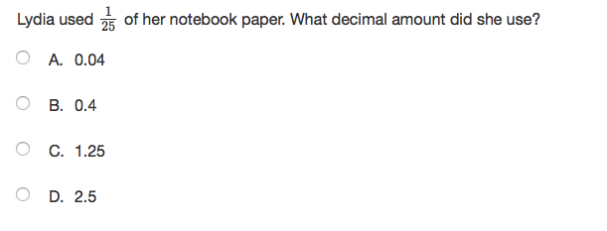

- 5.1.3.1 Add and subtract decimals and fractions, using efficient and generalizable procedures, including standard algorithms.
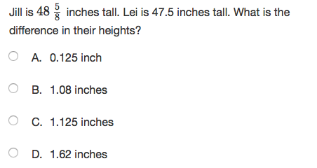
- 5.1.3.2 Model addition and subtraction of fractions and decimals using a variety of representations.
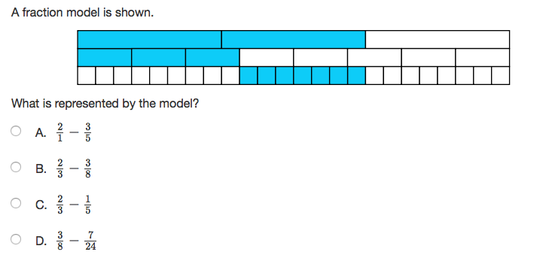

- 6th Grade: Multiply and divide decimals, fractions and mixed numbers; solve real-world and mathematical problems using arithmetic with positive rational numbers.

- 6.1.3.1 Multiply and divide decimals and fractions, using efficient and generalizable procedures, including standard algorithms.

- 6.1.3.2 Use the meanings of fractions, multiplication, division and the inverse relationship between multiplication and division to make sense of procedures for multiplying and dividing fractions.

Unit 1: Foundations of Fractions
Day 1 & 2: Identifying Fractions
Pretest: Pretest for Days 1-18: Foundations of Fractions
Identifying Fractions with Area Model
Fractions of an Area from Investigations
Sessions 1.1-1.2 Unit 6 pages 24-36
Finding halves, fourths , eighths thirds and sixths
Launch: Sandwiches….mmmmm. There is nothing better! I like them on bread rather than a bun ….how about you….continue short discussion about sandwich. Imagine that this rectangle is a sandwich. I want to eat half now and save half for later. I’m going to cut it like this.
Sandwich What fraction of the rectangle is this shaded piece?
What if I wanted to eat only ¼ of this sandwich? Use the Sandwich grid and show me a couple of ways to show ¼ of the rectangle
Explore: Students will work independently to explore Sandwich grid Additional Activity and Fraction Artist
Share/Summarize: As they work, ask them how they know that their piece is exactly one fourth of the whole rectangle. Students can share their thoughts by modeling on the Etools grid

Day 3: Modeling Fractions Other Ways
Number Line Exploration: Use e-toolkit from Everyday Math to model designated fractions using fraction circles, bar modeling, and number line.
Number line
Fraction Model
Thinking Blocks
Games
Launch: I can’t stop thinking about yesterday's discussion of sandwiches...lead into short discussion about sandwiches...There are fractions all around us! We can build fractions in food like pizza and a pan of brownies but are there other ways to explore what fractions look like or how fractions can be modeled?
Explore: Students will be independently using their ipads to explore the Everyday math e-tool kit.
Share: Students will be sharing their findings by switching groups and modeling what they have found to be helpful to model fractions.
Summarize:This lesson is and explorations of how fractions can be found in everyday life and how students can model the same fractions using different tools.

Day 4: Adding Fractions
Combinations That Equal 1 From Investigations
Session 1.6 Unit 6 Pages 52-57
Introduction to adding fractions
Adding fractions
Combinations that Equal 1

Launch: Man do I love chocolate! Who doesn’t love chocolate? Well, it just so happens that my husband knows how much I love chocolate and has asked my kids to always buy me some chocolate whenever they go on a trip. This is really cool! So last year my son went to Minneapolis to see a Wilds game and bought me ½ pound of cute little hockey stick chocolate. That very same weekend Hannah goes to Canada and comes home with 1/4 of a pound of little chocolates shaped like maple leafs. Thank goodness Tanner did not travel that weekend! I had plenty of chocolate. How do I find how much chocolate I have altogether?
Explore: Students will explore in groups of 4 adding fractions by coloring in grids, using connecting cubes and circle fraction pieces.
Share: As we work through the lessons I will be asking for students to share their findings either with manipulatives or on the board.
Summarize: This lesson involves concrete and representational methods to add fractions.

Day 5: Adding Fractions (continued)
Adding Fractions from Investigations
Session 1.7 Unit 6 pages 59-62
-Adding fractions
-Combinations that equal 1

Launch: Well the chocolate did not last long….Yep I ate it all and suffered the repercussions last night! Ugh did my stomach hurt! I just laid down in bed moaning until my husband came in and said I was hogging the bed. My husband is a pretty big guy and he thinks that because of that he should get more space on the bed than me! Can with a partner come up with a reasonable equation on how my husband and I can share the Whole bed and each have a reasonable portion?
Explore: Students will explore in groups of two adding fractions by coloring in grids, using connecting cubes and circle fraction pieces.
Share: As we work through the lessons I will be asking for students to share their findings either with manipulatives or on the board.
Summarize:This lesson involves concrete and representational methods to add fractions.

Day 6-7: Numerator/Denominator, Representing Fractions
Activity: Fraction Cards

Launch: This has been one long week...did you ever notice how some weeks seem to fly by and other just drag on…..short discussion about the week. “A week is divided into 7 days. What fraction of a week is 1 day of the week?”
Jack has a chocolate bar that was divided into 8 equal parts. What fraction of the bar are 5 of these parts?”
Explore:Students will be making fraction cards, in groups of 4 ,by modeling different fractions on a bar grid.
Share: Building and sharing ideas as they make fraction cards in a group of 4
Summarize: This group activity is a precursor to the next few days of playing several different games. This step can be skipped if you have access to the Everyday Math fractions cards.

Day 8: Numerator/Denominator, Representing Fractions (cont.)
Activity: Capture Fraction (like Top It)

Launch: Ok, the week is moving along….one more day closer to Friday...Isn’t it funny how Friday is such a big day …...continue conversation about the week and lead slowly into a quick discussion into fractions of a week. Over the next couple of days , we will be using the Fraction Cards you made to play a new game called Capture Fractions! In this game you will compare two fractions and decide which one is a larger portion of a whole ( or more than one whole) The player who has the larger fraction will take both cards!
Explore:Play game in pairs.
Share: Students will share some of the strategies that they use to decide which fraction is larger.
Summarize: In this lessons students use the cards from the previous lessons to visualize and decipher which fraction are nearer to a whole and/or greater than a whole.

Day 9: Comparing Fractions to Landmarks
Activity: Landmark Cards from Investigations

Launch: PIZZA PIZZA! Anyone remember that commercial...what company was that for? Just hearing it makes want pizza…. Lead into pizza discussion...Jenny had a pizza that was divided into 8 equal slices. She ate 3 of them. Danny has a pizza that is the same size, but his is divided into 4 equal slices. He ate 3 slices of his pizza. Who ate more an amount closer to the whole pizza?
Explore: Students will work in pairs or groups to move fractions on a line.
Share: Students will be using their Fraction Cards to place on the table according to the landmarks of 0, ½ , 1 and 2.
Summarize: In this lesson students will learn to use landmarks to help them sequence fractions

Day 10: Comparing Fractions to Landmarks (cont.)
Activity: Fractional Clothesline Activity
Launch: Do you have chores? One of the chores that I have is laundry. I really enjoy it in the summer. In the summer I love to hang the clothes out on the line...get that fresh air smell….do you know what I mean….Like the smell of fresh cut grass...cont. On with the story...
Explore: Small groups will work together to decide where their number cards will be on a line.
Share: This is a whole group lesson utilizing the entire room. Students work in group for all to see.
Summarize: In this lesson , a string will be stretched across the classroom and various points will be marked for 0,1,2,3,4. This classroom number line will be used to show that all the proper fractions are grouped between 0 and 1, and al the improper fractions or mixed numbers are all grouped above 1.

Day 11: Fractions on a Number Line
Activity: Investigations Session 2.5 pages 24-31
-Comparing ⅜ and
-Activity Fractions on a Number Line
-Making a Fraction Number Line
-Capture Fractions or Fraction Tracks Game

Launch: On a day like this I would love to take a swim. How many of you know that feeling of floating in the water? Cont. story ...bring in pool swimming and the markers swimmers see at the bottom of the pool...
Six friends are swimming in a 1 mile race at the lake. Each swimmer has a lane marker to lead them to the finish line. The fractions tell how much of the 1 mile distance they have swam.
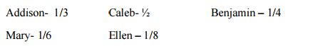
Place each swimmer on their lane marker (number line) to show where they are between the start and finish. Be as exact as possible when you show where each swimmer is in the race.”
Explore: Student pairs will be placing their fraction cards on a number line.
Share: Students will be sharing their thoughts and reasons about the fraction relationship to landmarks.
Summarize: This lesson has students working with fractions and where they are located on a number line

Day 12: Equivalent Fractions
Launch Activity: Equivalent Fractions with Pattern Blocks

Activity: Fraction Strips to show Equivalence
Activity: Fractions Spoons Game
Launch: “I can clearly remember when I first moved from Barron, WI. to Eau Claire, WI. I had to get used to a new neighborhood, remember the names of streets, and especially know where the grocery store, school, and library were located.”

“Kim and Matt are moving to a new town. Their new house is 18 miles from their old house. The moving truck drove their belongings "12" /"12" of the way. Is that far enough?”
Explore:Students will demonstrate in pairs the understanding that a fraction is part of a region. Identify fraction relationships among pattern blocks.
Share:“Is there a way to represent the red trapezoid using blue and green pattern blocks? Can you cover the red trapezoid using only one color? What does this tell us about the relationship between the blue rhombus and the green triangle?”
“Are there other ways to represent various pattern blocks (for example, the yellow hexagon) using more than one color pattern block?”
Summarize: Students will understand that a fraction is part of a whole. They will state the relationship between the pattern block shapes [e.g., that there are three triangles in one red trapezoid].

Day 13-17: Addition and Subtraction of Fractions
Rational Number Project - Lesson 21,22, 23
http://www.cehd.umn.edu/ci/rationalnumberproject/RNP1-09/RNP1-09_withBlankPages.pdf

Drop Zone: Adding Fractions with Like and Unlike Denominators Utilizing Strategy

Looking for Patterns in Subtraction of Fractions
Launch: “I love ordering pizza from Do North! My favorite is their pizza taco. Has anyone tried their pizza?”

“Alice noticed that there was 3/4 of a pizza left after the party. She ate a slice of pizza that was the size of 1/8 of a whole pizza. How much pizza was left after Alice ate a slice?”
Explore:Students work in pairs or in small groups try to act out the problems using fraction circle pieces
Share: Randomly select a student to explain how his/her group attempted to act out the problem. Deemphasize an exact answer, but help students verbalize their group’s reasoning and discussion
Summarize:Students explore fraction subtraction within take away and difference contexts. Students estimate and solve story problems with fraction circles.

Day 18: Mixed Numbers and Improper Fractions
Digging Up Improper Fractions

Post-Test for Days 1-18: Foundations of Fractions

Launch: “Sometimes I like to challenge my friend to running laps around the track. Most of the time they run faster than me. On a good day, I can run faster than them.”

“Alisha, Alex, and Eric wanted to see who could run the farthest. Alex ran $\frac{10}{8}$ miles and stopped. Alisha ran $\frac{14}{8}$ miles and stopped. Eric stopped halfway between where Alex and Alisha stopped. How far is Alex from Alisha? How far is Eric from Alisha?”
Explore:Students work in pairs to locate improper fractions on a number line
Share: Students will share their points achieved on an anchor chart
Summarize: This lesson provides a hands-on approach to converting improper fractions to mixed numbers.

Unit 2: Multiplying Fractions
Day 19-21: Multiplying fractions and whole numbers
Pretest for Days 19-25: Multiplying Fractions

Materials: unifix cubes, paper, pencils, markers, whiteboard, and dry erase markers

Launch: “I sure love soft chocolate chip cookies! How many of you like cookies? What kind of cookies do you like?” “A group of students went to a cookie shop. If 3 students each ate $\frac{1}{2}$ a cookie, how many cookies did they eat in all? How can we model that using unifix cubes?”
Hand out 3 sets of unifix cubes (stacks of 10) to each student. Students will model multiplication situations, and the teacher will demonstrate the mathematical steps using the whiteboard.
“Show me 3 groups of 6,…”
“How can we represent groups of using a symbol or sign? (x)”
“Now, the stick of 10 cubes represents a whole, not a ten...”
“Show me 3 groups of 1/2.”
“Show 1/2 groups of 3.”
“Show me 1/5 of 10. This is shown with 2 cubes from each of the wholes (20 cubes) or taking the whole set of 10 rods and breaking that into 5ths.”

Explore: Students explore in pairs. Students will learn to use drawings to represent the models they are practicing with. These drawings will help them solve problems when numbers are too large to use manipulatives.

Students will work in pairs and find the unit fraction of the whole number, then use that to find a different fraction of the same whole number.

For example: 1/7 of 14 then 3/7 of 14

Find the product

Share: Students will share their observations and new strategies they have discovered.
Students should gradually move away from the drawing to the procedure of dividing the whole by the denominator and then multiplying by the numerator.

Summarize: Review with students that there are many ways to show how to solve multiplying fractions. Review the different ways we discovered to solve math problems.

Multiplying Fractions and Whole Numbers (Cont.)
(Taken from Learnzillion.com and Math Course 1, McDougal Littell © 2007)

Launch: “Have you ever had a disagreement with a friend?” “Erin and Nabeel are having a mathematical argument. Erin says four jumps of one-third is more is more than two jumps of two thirds. Nabeel says he disagrees with that. Who do you think is correct?”

“How would you describe the differences between the two ideas? What do you think Erin's mistake is? How would you help Erin and Nabeel settle their argument? How would a number line help you represent the two ideas?”

Explore: Students will work in groups of 3. Students will use their prior knowledge, and come up with a plan on how to solve the given math problem.
“How did you record your solution? How can the number line help you show your thinking?”
Task-Specific Questions:
How do the size of the pieces and the number of pieces compare?
If you think of as 2 x , how does that change the meaning of the expression? Use the number line to help you explain.
How might you use the associative property in solving this problem?
How is 3 x related to 3 x ( 2 x ) or (3 x 2 ) x ?
If you change your answer to a mixed number, what do you notice?

Task and Sharing
Share:
“Why can't you just multiply both the numerator and the denominator by the whole number?”
“How is 4 times 2/3 different from 4 times 2/ 4 times 3?”
“How is 2 × 3/8 like 6 × 1/8?”
“What is the relationship between the numbers in 2 × 3/8 like 6 × 1/8?”
“Think of another example of multiplying a whole number by a fraction. What is a related expression to the one you thought of?”
“Can you always express a non-unit fraction as a multiple of a unit fraction? Why or why not?”
Summarize: “When multiplying whole numbers by fractions, there is a relationship between fractions and whole numbers.”
Extension- practice: Students will choose five math problems to work on from Math Course 1, McDougal Littell © 2007, Lesson 7.1.

Days 22-23: Multiplying Fractions
(Taken from Learnzillion.com and Math Course 1, McDougal Littell ©2007)
Materials: Unifix cubes, paper, pencil

Launch: “I love chocolate cupcakes! How many of you like cupcakes?”

“Rob is making some cupcakes for his school’s fundraiser. A cupcake recipe asks for $\frac{3}{4}$​​start of a cup of butter. Rob wants to make $\frac{1}{3}$of the original recipe. How many cups of butter will Rob need? How can we model this?”

“You will learn how to model the product of two fractions.”
Modeling Products of Fractions

See Math Course 1, McDougall Littell ©2007, 7.2 pg. 346.

Explore: Students will work in groups of two to model the product using the given math problems:
Multiplying Fractions Models

Share: Students will share their work and explain their answers. Students should gradually move away from the drawing to the procedure of multiplying fractions.

Summary: “In this lesson you learned how to multiply fractions by other fractions by multiplying across the numerators and denominators.”

Multiplying Fractions (cont.)

(Taken from Betterlesson.com)

Launch: “On warm sunny days I like go out for a run. I usually run a lap to the school and back. When I want to challenge myself I go to the mini-mart.”

“Jenny’s house is $\frac{4}{7}$ of a mile from the bus stop. If Jenny had to run $\frac{2}{3}$ of the way from her house to the bus stop, what portion of a mile did Jenny run?”

“Today you will draw your ideas on your own paper to help you communicate with your group members.”

Explore: Students will work in groups of 2-3 to model the product using the given math problem:

Jenny's Problem

Share: Students will share how they solved their answer using different diagrams.
“Does your answer make sense? How do you know?” Students should realize that because they are multiplying two fractions that are smaller than one, their answer is smaller than each of the factors.

Summary: “In this lesson you practiced how to use a model to multiply fractions by other fractions.”

Days 24-25: Multiplying Mixed Numbers
Launch: “Last night I had to make two batches of cookies. I forgot to set the timer and burned my first batch. The second batch came out perfect! Has this ever happened to any of you?”

“A group of students went to a cookie shop. If four students each ate 2 $\frac{1}{2}$ cookies, how many would they have ate in all?”

“In this lesson you are going to learn how to multiply mixed numbers by renaming the factors as improper fractions.”
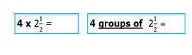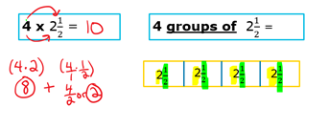
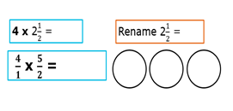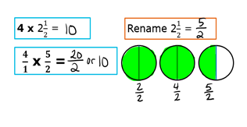

Explore: Students will work in groups of 2-3 to model the product using the given math problems:

On Saturday $\frac{1}{4}$of an inch of rain fell every hour. If it rained for 2 $\frac{2}{3}$hours on Saturday, how many inches of rain fell?

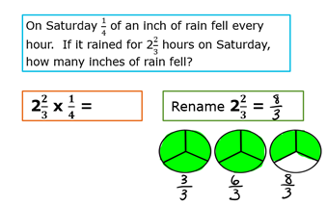

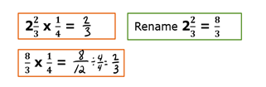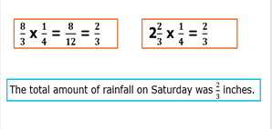
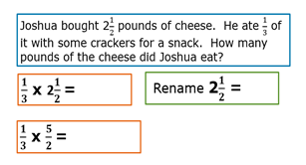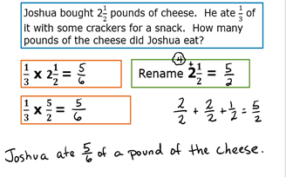

Launch: “Last night I was craving mint chocolate chip cookies. So I tried to make a batch, but added too many mint chips. After trying a second and failing a second time, I went to the store and bought some instead. What could have I done to make a better batch?” “A cookie factory puts 2 $\frac{3}{4}$barrels of flour into each batch of cookies. How much flour will the factory use for 4 batches?”

“You will use pictures and repeated addition to prove that you can compute with the standard algorithm.”

Multiplying fractions and mixed numbers

(Taken from worksheetsworks.com)
Students will practice working on math problems.
Multiplying fractions and mixed numbers

(Taken from Kahoot.com)
Students will then multiply fractions with mixed numbers on Kahoot!.com
Kahoot! Multiplying mixed numbers

Share: Students will share how they solved their answers using a diagram, and other strategies they have used.

Summary: “In this lesson you learned how to multiply mixed numbers by renaming the factors as improper fractions, and you used pictures to illustrate the multiplication of a mixed number. This allowed you to see that the standard algorithm works for mixed numbers when they are expressed as improper fractions and to solve a problem using the standard algorithm.”

